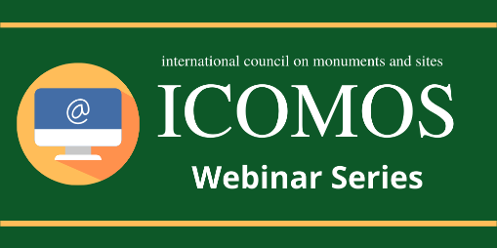
ICOMOS Upcoming Webinars
Template

In order for your webinar to appear on the ICOMOS’ website “Upcoming Webinars” article, please fill out the following template and send it to project.intern@icomos.org
The “Upcoming Webinars” article will be included in each monthly ICOMOS e-news.

Webinar Title
Name of ICOMOS Committee or Working Group organizing the webinar
Name and email address of contact person
Date and time of the webinar
Summary of the webinar (max. 100 words)

How to participate in the webinar (a link to register or to watch the video)
Webinar poster | □ I enclosed it in the e-mail  or  □ Here is the poster download link:
A link to a full article on the webinar or a pdf document providing more information about the webinar (optional)

