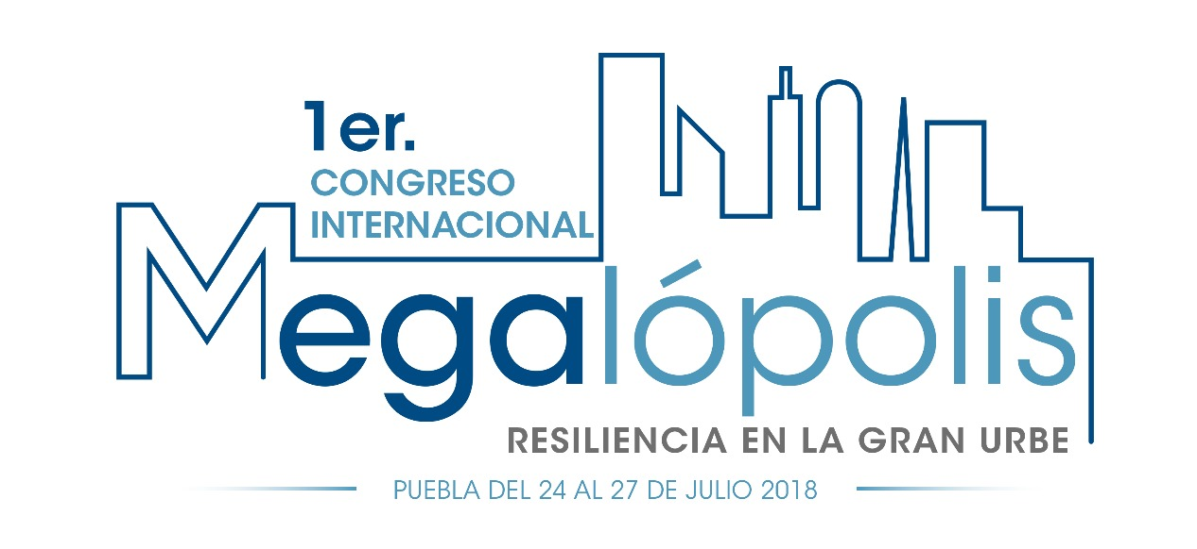

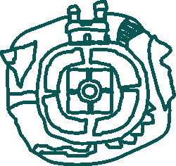

Introduction

The 1st. International Congress Megalopolis: Resilience in the large city, will take place in Puebla, México from July 24 to 27 2018. It is organized by the Government of Puebla in partnership with the newspaper Megalópolis, the Instituto de Administración Pública del Estado de Puebla, Benémerita Universidad Autónoma of Puebla, IGC Asesores among other institutions.

The Megalopolis congress aim to be a space of knowledge, experience exchanges and reflections about the cities and megalopolis, the problems they currently face and the ones that are coming their way such as, natural catastrophes, floods, limited mobility, social, cultural and political changes. Those issues are above territorial limits and must be addressed in partnership and collaboration with actors from vast regions.

Megalopolis form when big cities join in a geographically or administrative way, they gathered in their territory a huge amount of political, social and financial power. They are seem as an engine of economic growth and the epicenter of the governmental decision making. Organizations like the World Bank point that in 2050 about 70% of world population will be living in urban areas.

In order to contribute in the creation of cities that become engines for prosperity and centers for sotial and cultural development, in the last years many countries has included in their agendas initiatives related with sustainable development actions, the most relevant of them is the 2030 Agenda for sustainable development and the New Urban Agenda.

The 2030 agenda for sustainable developmente was approved in 2015 by the countries members of the UN and recognizes five critical areas for the humanity and the planet: people, planet, prosperity, peace and partnerships. These goals aim for the collaboration of a diverse set of stakeholders to address the big problems faced by humanity.

The New Urban Agenda focuses on sustainable urban development, analyze the economic, environmental and cultural factors that foster human settlements capable of addressing the current and future challenges. To create this agenda 22 key themes were included. The international congress Megalopolis plans to select one of those 22 key themes, to drive the dialogues of it each congress edition.

The complexity of the challenges faced by the cities, as well as natural shocks and long-term stressors agents, makes us aware of the need of understanding and collaboration among international, national and local institutions and society to create strong resilient cities. In this edition the topic selected is Resilience in the large city.

The term resilience is related with many disciplines, in a broad definition it refers to the ability to face and recover from shocks or hazards. In an urban context, urban resilience refers to the capacity of individuals, communities, institutions, businesses, and systems within a city to survive, adapt, and grow no matter what kinds of chronic stresses and acute shocks they experience.

The congress is willing to encourage the participation of national and international public servants, universities, Research centers, students and public interested in discussing the challenges to work for resilient cities and to share experiences trough keynotes, panels and dialogue tables.

Key themes

The International congress Megalopolis Will focus on the theme resilience in the large city, through frameworks, experiences and perspectives that contribute to develop resilience in cities, megalopolis and in the people that inhabits them. The activities prepared for this congress include:
Conferences

Panels

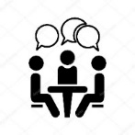
Dialogue Tables

To strengthen the resilience capacities in cities and reduce the risks caused by natural disasters is one of the many compromises included in frameworks like the 2030 sustainable development agenda, the sustainable development goals and the New Urban Agenda. This frameworks, among others, will be taken as a reference of the themes that will be discussed during the congress.

Dialogue Tables
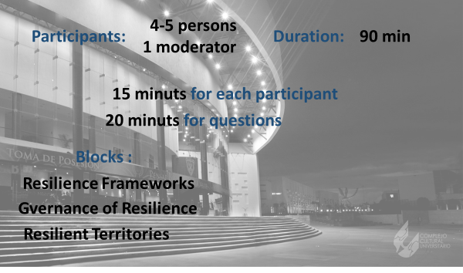

The theme of the congress, resilience in the big city will be address in 12 dialogue tables that will have speakers from diverse backgrounds and expertise, the tables are grouped in 3 thematic blocks that are explained below:
Block 1  Resilience Frameworks | Aim to show diverse perspectives and tools that international organizations, national and local governments, education institutions and NGO´s use to work towards resilience in cities and megalopolis and that are related to people, planet, prosperity and peace.
People | Planet | Prosperity | Peace
This table is dedicated to initiatives, programs or frameworks used by diverse organizations that works towards resilience in cities and megalopolis. | This table is dedicated to initiatives, programs or frameworks used by diverse organizations working in the sustainable use of the planet resources that foster resilience in cities and megalopolis. | This table is dedicated to initiatives, programs or frameworks used by diverse organizations to face and reduce the economic consequences of natural and social disasters in the cities, megalopolis and their habitants. | This table is dedicated to initiatives, programs or frameworks used by diverse organizations working for peaceful cities and social resilience in the face of violence and conflict.

Block 2  Governance of resilience | The processes, relations and institutions that cities and megalopolis must develop and enhance resilience. This set of dialogue tables include the discussion of the chronic stressors of the cities such as the rule of law, political conflicts, economic crisis, social problems and other phenomena that affect people, planet, prosperity and peace in the cities.
People | Planet | Prosperity | Peace
This table will analyze actions of social intervention in favor of building resilience in cities and megalopolis. The mechanisms institutions, legal frameworks and social relations that need to create synergy in favor of resilient cities. | This table will present mechanisms, institutions and tools that work in favor of minimizing the environmental impact of the human activities in the cities and help with the sustainable management of the resources of the planet. | This table will present mechanisms, institutions that are used by cities to face the economic costs of natural disasters and other chronic stressors and to produce resilient and prosper cities. | The elements of social fragility and the political and cultural stressors that may cause disturbance in the cities and threaten peace will be discuss in this table, as well as the mechanisms, institutions and tools to treat this problem.

Block 3  Resilient Territories | The challenges face by the territories where cities and megalopolis are located and the actions that may help in building up resilience conditions. Some of the topics includes in this set of tables are climatic change, earthquake zones, migration, the uses of land, lack of water, mobility among others, and their relationship with the people, planet, prosperity and peace.
People | Planet | Prosperity | Peace
This table will discuss how the peculiarities of the territory where cities and megalopolis are settled impact the way of living of their habitants and the actions that need to be taken in other to face the challenges and develop resilience. | The focus of the dialogue will be on the sustainable coexistence of the humans and the territory, considering the natural risks associated with the characteristics of the territory of the cities. | Here will be presented the experiences of how cites and megalopolis have develop economic resilience in the face of extraordinary events, natural disasters and challenge of the territory. | This table focus on the interactions of the many groups and actors that live in cities and megalopolis and the ways to develop peace, stability and resilience.

Participation of IComos
We consider your paticipatio in the dialogue table of prosperity of the block Governance of resilience
Dialogue table: | Prosperity_ Governance of resilience
Description: | This table will present mechanisms, institutions that are used by cities to face the economic costs of natural disasters and other chronic stressors and to produce resilient and prosper cities.
Date: | Wednesday 25 of July 2018
Participant: | Icomos – Please add the name of the person designated
Explanation | Since ICOMOS works for the conservation and protection of cultural heritage places it is possible that their experiences in how to reduce the impacts and manage the effects of natural disasters and long-term stressor agents in the cities may be useful.

If you consider that you background, experience may be more suitable in other table, please inform us for the possibility of arranging a change.

Definition from 100 Resilient Cities of the Rockefeller Foundation.

