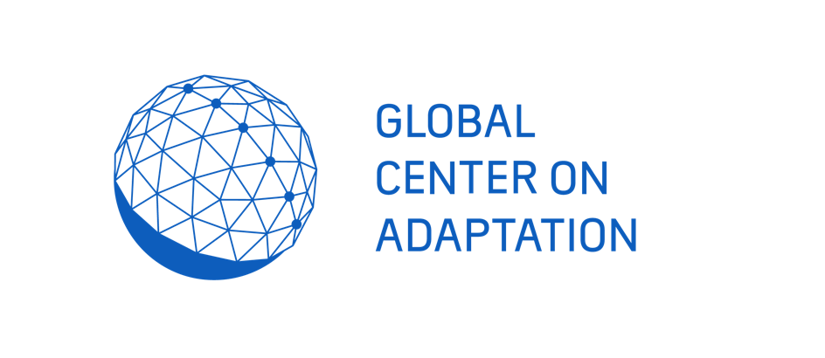
WAC WEBINAR SERIES

2020

WEBINAR 03: WATER AND SPIRITUALITY FOR CLIMATE ADAPTATION

Rationale

People have always understood the value of water to sustain life, health, economies and ecosystems. A lot of cultural heritage has been built around water over the millennia. Examples are civil structures for water supply and for defence against water-related perils, for navigation, and for the generation of energy. Also part of this heritage are the governance systems set up for equitable and efficient management of water resources. Besides, societies and religions have developed a multitude of visions, rituals and practises related to water.

Despite the abundance of water-related cultural heritage, its significance for present and future climate challenges is not widely recognised. This partly due to the complexity of our relationship with water, and partly because of disciplinary and institutional divides between water managers and heritage experts.

The ICOMOS International Scientific Committee on Water and Heritage (ISC Water) works on bridging these divides-- through dialogues among political, professional and spiritual leaders, interdisciplinary research, collection and dissemination of best practises, and development of guidelines. For the Global Adaptation Summit held in January 2021, ISC Water organised a webinar that articulated how the cultural heritage of water can prove to be a source of adaptive capacity in the face of climate change. (Watch: https://vimeo.com/498348043).

As a contribution to the UNFCCC COP 26 to be held in Glasgow, UK (November 2021) and to kickstart the Community of Practitioners on Water and Heritage, GCA’s Water Adaptation Community (WAC) and ISC Water are organising a dialogue among spiritual leaders, who will discuss water-related spirituality as a source of inspiration and wisdom to cope climate change impacts on the water cycle—such as the increase in the frequency of droughts, floods and storms. This will be a precursor to the dialogue among spiritual leaders to be held at the UN Water Decade Mid Term Review to be held in New York (2023).

Key questions addressed

- What does a spiritual view on climate challenges look like?
- Can spirituality prove to be a source of resilience to climate change effects?
- How do we build upon our water-related cultural heritage, to forge strategies for climate change adaptation?

Date and Time

- 19 October, 2021
- 13.00 PM – 14:30 PM CET (Click here for local timings)

To participate, please register here

Programme

Moderator: Sergio Ribeiro, Director General of CIRAT, Brazil, and Board Member of ICOMOS ISC Water
13:00- 13:05- Introduction by the moderator

13:05- 13:15- A vision on adaptation to climate change in the Laudato si’, the second encyclical of Pope Francis : Ms Maria Hammershoy, Secretary General, Caritas Denmark

13:15 – 13:25 – A vision on adaptation to climate change Mr. Núñez, Leader of the Wa:k Community San Xavier District of the Tohono O'odham Nation near Tucson, Arizona, USA and Ms. Mona Polacca, Native American Spiritual Elder

13:25 – 13:35 – A vision on adaptation to climate change: Valériane Bernard, Brahma Kumaris World Spiritual University UN Representative

13:35 – 13:45 – A vision on adaptation to climate change- A Buddhist Perspective: Venerable Chan Master Hsin Tao, Founding Abbot of the Linj Jiou Mountain Buddhist Society and Founder of the Museum of World Religions

13:45 – 13:55 – A vision on adaptation to climate change- Perspective of a spiritual leader from Brazil (TBC)

13:55 – 14:05 – A vision on adaptation to climate change- An Islamic Perspective (TBC)

14:05 – 14:15 – Reflection on the dialogue by representative of the Committee of Religious NGOs at the United Nations

14:15 – 14:30 – Conclusions and Next Steps: Moderator

Outcomes

1. Launching a global dialogue on the significance of spiritual heritage and wisdom as means to cope with climate change impacts, leading up to the UN Water Decade Mid Term Review in 2023

2. To initiate a community of practitioners on the significance of spiritual heritage for water-related climate adaptation

