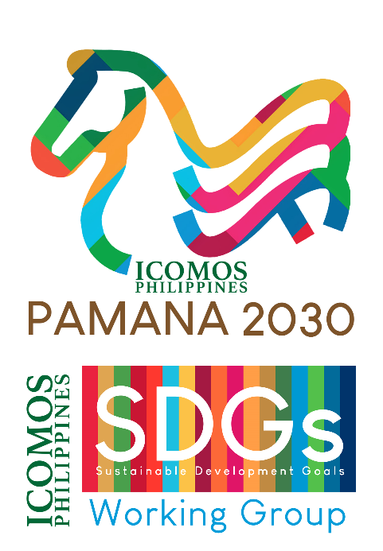
ICOMOS is participating at the ICOMOS Philippines – Sustainable Development Goals Working Group’s Campaign Launch for the Philippine Heritage and the 17 SDGs, “𝗣𝗔𝗠𝗔𝗡𝗔 𝟮𝟬𝟯𝟬: 𝗨𝗻𝗺𝗮𝘀𝗸𝗶𝗻𝗴 𝘁𝗵𝗲 𝗦𝗗𝗚𝘀 𝗶𝗻 𝗖𝘂𝗹𝘁𝘂𝗿𝗮𝗹 𝗛𝗲𝗿𝗶𝘁𝗮𝗴𝗲 𝗳𝗼𝗿 𝗦𝘂𝘀𝘁𝗮𝗶𝗻𝗮𝗯𝗹𝗲 𝗗𝗲𝘃𝗲𝗹𝗼𝗽𝗺𝗲𝗻𝘁”, with expert contributions as speakers to the online webinar.
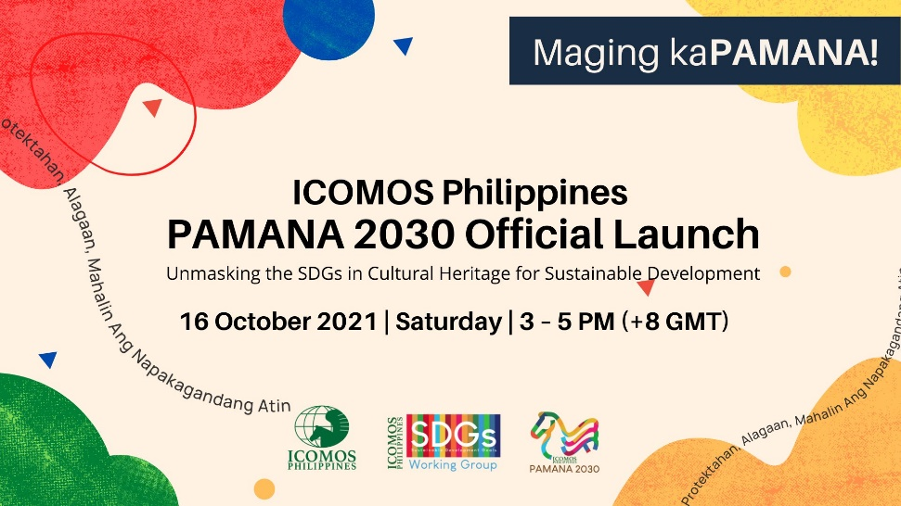
SDGWG Philippines established the PAMANA 2030 together with ICOMOS Philippines as part of localizing the ICOMOS International Policy Guidance document to provide baseline information of the context of Philippine Heritage to support Local Government Units (LGUs) and to show that heritage can be a driver and enabler of inclusive, equitable, Sustainable Development.

𝗖𝗮𝗺𝗽𝗮𝗶𝗴𝗻 𝗹𝗮𝘂𝗻𝗰𝗵 𝗽𝗿𝗼𝗴𝗿𝗮𝗺𝗺𝗲
For the first time, ICOMOS Philippines will be localizing the United Nations’ 17 Sustainable Development Goals (SDGs) for the Philippine Heritage! Join Philippine Heritage practitioners & advocates, government officials / public servants, Local Government Units (LGUs), academicians, students, and other stakeholders across the Philippines for five presentations and speeches on 𝗢𝗰𝘁𝗼𝗯𝗲𝗿 𝟭𝟲, 𝟮𝟬𝟮𝟭, 𝗦𝗮𝘁𝘂𝗿𝗱𝗮𝘆, 𝟯 – 𝟱 𝗣𝗠 (+𝟴 𝗚𝗠𝗧) 𝗣𝗵𝗶𝗹𝗶𝗽𝗽𝗶𝗻𝗲 𝗧𝗶𝗺𝗲.
The presentations include the potentialities of the SDGs for Heritage, its inclusion in the United Nations Agenda 2030 and mobilization for the Decade of Action, and ICOMOS Philippines’ efforts in localizing the 17 SDGs for the Philippine Heritage.
The following ICOMOS members will present: Ms. Maria Cristina Paterno, MS, President and Board of Trustee of ICOMOS Philippines; Emeritus Prof. Arch. Sofia Avgerinou Kolonia, PhD, Former Chairperson of the Sustainable Development Goals Working Group (SDGWG) International 2016 – 2017; LArch’t. Gabriel Victor Caballero, MA WHS, Current Focal Point for the United Nations Sustainable Development Goals of ICOMOS International; and Arch’t. Kenneth J. Tua, UAP, MSc – MA DYCLAM+, MA CDIR, Task Team Coordinator, SDGWG Philippines. To be moderated by Dr. Laya Boquiren – Gonzales, PhD, Policy Guidance Task Team Member, SDGsWG Philippines.
With a keynote speech from Her Excellency Atty. Maria Leonor "Leni" Gerona Robredo, 14th and incumbent Vice President of the Philippines, Office of the Vice President of the Republic of the Philippines.
The campaign launch webinar is being held by ICOMOS Philippines and SDGWG Philippines. For more information, please like and follow the official campaign Facebook page: https://www.facebook.com/PamanaPH2030/ and to register for the webinar, visit the link here: https://tinyurl.com/RegisterPAMANA2030

