Connecting Practice
Call for Interest

What is Connecting Practice?

The Connecting Practice project aims to explore, learn about, and create new methods of recognition and support for the interconnected character of the natural, cultural and social value of highly significant land and seascapes and affiliated biocultural practices. The project is a joint initiative between IUCN and ICOMOS, providing the opportunity for influencing a shift in conceptual and practical arrangements for the consideration of culture and nature within the implementation of the World Heritage Convention.

Following the successful work done in the first two phases of Connecting Practice, the third phase will continue to explore relevant information gathered as part of the project, and to implement lessons learned into practical interventions and new mechanisms for achieving positive results for agricultural and biocultural practices. This third phase of the project will focus specifically on evolved cultural landscapes, and will explore how to best support and sustain traditional management practices and change management within the processes of the World Heritage framework.

If you are interested in participating in the project, please answer the following questions and send your responses to maureen.pelletier@icomos.org by 30 September 2018. Please limit your response to 500 words.

- Does your site demonstrate significant biocultural values? Please explain.

- Please define the traditional management practices used at your site and how they are managed.

- Has your site been designated as GIAHS (Globally Important Agricultural Heritage Systems)?

- How could you contribute to the third phase of the Connecting Practice project? Please explain your interest in participating.

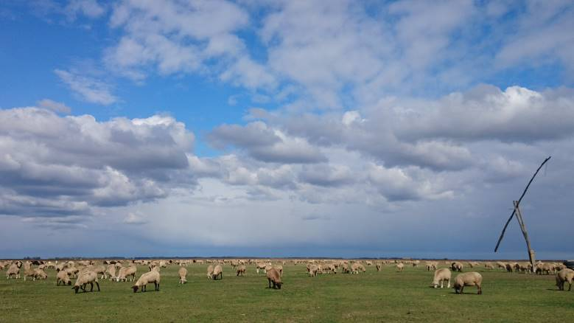
Sheep Grazing in the Puszta, Hungary – one of the sites of Connecting Practice Phase II © Goran Gugic

