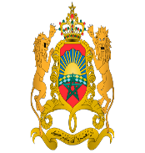 |  | 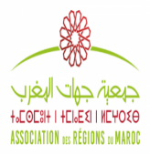 | 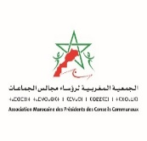 |  |  | 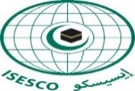 |  | 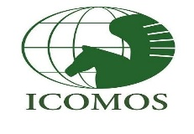 | 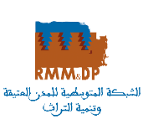

On the Occasion of the Celebration of the International Day of World Cultural Heritage Monuments & Sites

International Conference on:
«PROTECTING THE CULTURAL HERITAGE THROUGH A PARTICIPATORY AND INCLUSIVE GOVERNANCE TO MEET THE SUSTAINABLE DEVELOPMENT GOALS»
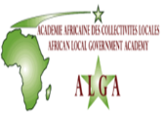

Wednesday, April 18, 2018 at ISESCO Headquarters at 9h00am

with the Support of:
Together for an Effective Local Africa |  | 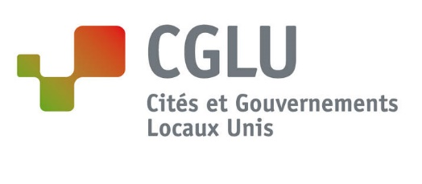

AGENDA

Time | Activities
8h00 | - Arrival and registration of the Guests & Participants
9h30 | - Official Opening of the Conference
- Address by His Excellency Dr. Abdulaziz Othman Altwaijri, Director General of the Islamic Educational, Scientific and Cultural Organization (ISESCO).
- Address by His Excellency Mohamed El Aaraj, Minister of Culture and Communication, Kingdom of Morocco
- Address by Mr. Mohamed Saddiki, Mayor of the City Council of Rabat.
- Address by Mr. Abdelati Lahlou, President of the International Council of Monuments and Sites - Morocco (ICOMOS-Morocco).
- Address by Mr. Karim Hendili, Program Specialist for Culture, UNESCO Office in Rabat
10h30 | - Presentation of the Program of the Conference
 | - Coffee break and group photo
11h00 | Plenary Session 1 : Heritage Protection, a Fundamental Dimension of Sustainable Development  - The Role of Culture in the Sustainable Development, by Madam Catherine Cullen, United Cities and Local Governments (UCLG) Special Advisor on Culture in Sustainable Cities, former President of the Committee of Culture of UCLG.  - The Role of the Networks of Cities in the Promotion and Enhancement of the Heritage - Case of the Mediterranean Network of Medinas and Heritage Development, by Mr. Mohamed SEFIANI, President of the Communal Council of Chefchaouen, President of the Mediterranean Network of Medinas and Heritage Development (RMM & DP), Kingdom of Morocco  - The Moroccan Strategy to promote Culture and Cultural Heritage, by Mr Abdellah Alaoui, Ministry of Culture and Communication, Kingdom of Morocco.  - Morocco, the Historicity of the Concept of Sustainable Development in the Traditional Urbanistic and Architectural Model, by Madam Afaf Ellouali, Architect specializing in Historical Heritage, Secretary General of the Association Meknes Heritage, Kingdom of Morocco
 | - General Discussion
13H00 | - Lunch
14h00 | - Parallel Thematic Sessions
Thematic Session 1 : Participatory and Inclusive Governance in the Protection,
Safeguarding and Enhancement of Heritage
- The human and natural risks that threaten the Architectural Heritage of Moroccan Cities: case of the City of Rabat, by Mr. Mohamed Es-Semmar, Director of Historical and Archaeological Heritage at the Agency for the Development of the Bouregreg Valley, Kingdom of Morocco
- The involvement of local communities in the protection, management and enhancement of sites and monuments in Africa: challenges and perspectives, By Mr. Samuel Kidiba, Director General of the School of African Heritage (EPA), Republic of Benin.
- The Participatory Budget for the protection and enhancement of historic sites, by Mr Fakih Nasar Lanjri, General Coordinator of Projects, RMM & DP, Kingdom of Morocco.
- The experience of Cameroon in the promotion of Cultural Heritage, by Mr. Aimé Sadou, Cultural Expert Consultant, Ministry of Arts and Culture, Cameroon.

Thematic Session 2 : Mobilization and Efforts of International and Regional Organizations and their pioneering experiences in the Protection, Safeguarding and Valorisation of Heritage
- The Experience of ISESCO: Protection, Safeguarde and Enhancement of Cultural Heritage in Member Countries, by an Expert of ISESCO.
- Issues and Challenges of Protection, Safeguarding and Enhancement of Cultural Heritage for Sustainable Development, by Mr. Karim Hendili, Program Specialist for Culture, UNESCO Office fo Rabat
- The experience of UCLG-Africa: Training, Learning and Capacity building, the role of ALGA of UCLG Africa, by Dr Najat Zarrouk, Director of the African Local Government Academy of UCLG Africa, Kingdom of Morocco
16h00 | - Coffee break
16h30 | Plenary Session 2
- Presentation of the Recommendations of the Conference
- Closing speech
- Address by Mr. Jean Pierre Elong Mbassi, Secretary General of United Cities and Local Governments of Africa (UCLG-Africa).
17h30 | End of the work.

